# Experiment No. : 5

**Date : 21 September 2021**

**Name : Shaunak Deshpande**

**Roll no : 39**

**Gr. No. : 11911180**

1. METER IN CIRCUIT

A meter in circuit manly uses flow control valve and check valve. Meter-in circuits work well with hydraulic fluids. Meter in circuits are used for controlling of extending velocity of a piston in cylinder.

Working of a meter in circuit Meter-In flow control circuit restricts fluid as it enters an actuator port. Meter-in circuits works well with hydraulic fluids, but can give erratic action with air.

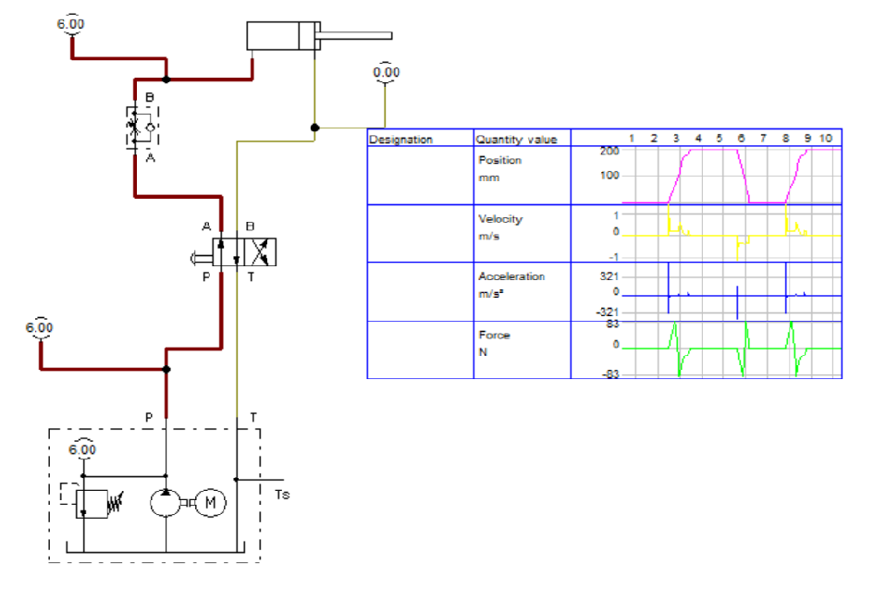

**2)** METER OUT CIRCUIT

meter-out flow control circuit that restricts fluid as it leaves an actuator port. Meter-out circuits work well with both hydraulic and pneumatic actuators.

The directional control valve shifts to straight arrows and pump flow bypasses the upper flow control to go to the cylinder cap end. Fluid leaving the cylinder rod end is held back before it goes to tank -- even with an external load trying to move it. The cylinder extends at a reduced speed in both hydraulic and pneumatic circuits until it meets a resistance it can't overcome or it bottoms out.

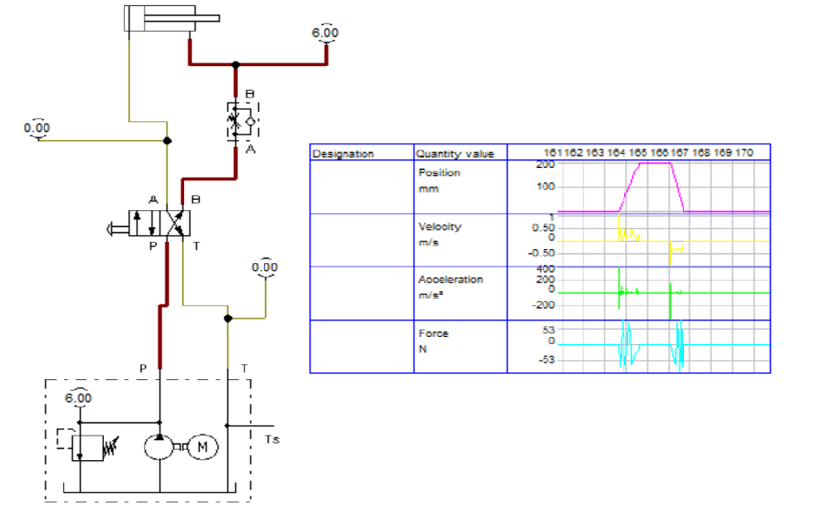

1. **Two hand operation of SAC using Two 3/2 DCV**

.

Bleed-off flow control circuits are found only in hydraulic systems and normally only in those with fixed-volume pumps. There is little or no advantage to using this type flow control with pressure-compensated pumps. A needle valve's inlet is teed into a line going to the cylinder and its outlet is connected to tank. The circuit only works with one actuator moving at a time because all pump flow goes to the presently operating function.

When the directional valve shifts, all pump flow passes through it and toward the actuator. On the way to the actuator, part of the flow is bled off to tank, so the actuator does not reach full speed. Excess flow goes to tank at low pressure. Many circuits only perform work at the end of stroke so this flow control system saves energy while the actuator moves to and from the work position, yet still gives good speed control.

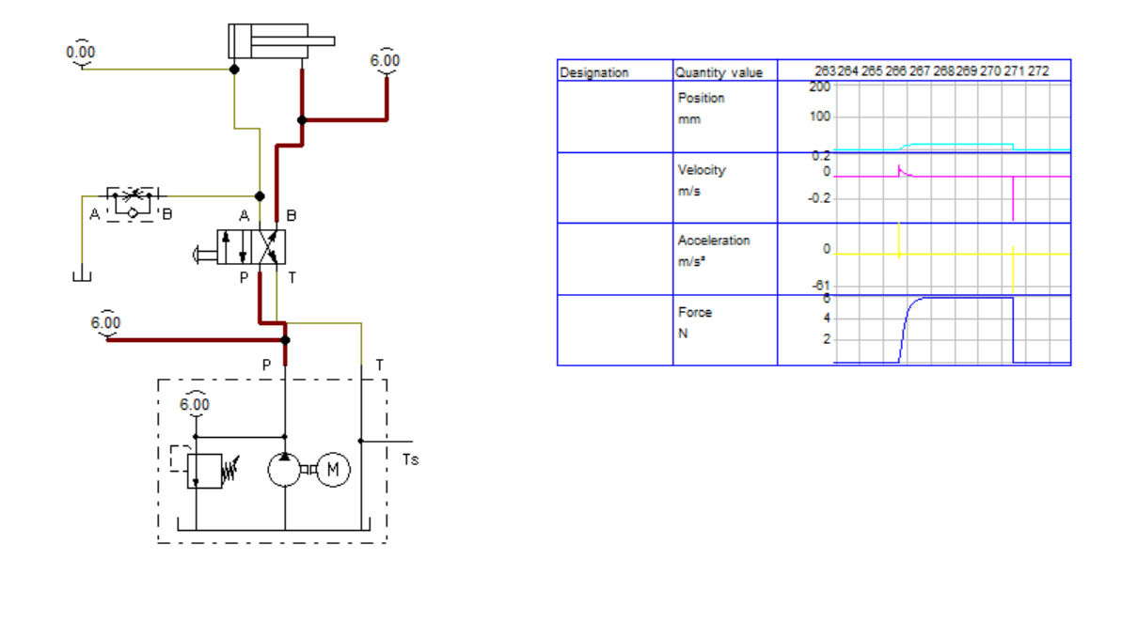

1. **4 /2 valve to operate BI-direction Motor**

A 4/2 directional control valve would have four ports and two spool positions.

Ports are located on the manifold to which the directional control valve is mounted, and are used as connection points to the system

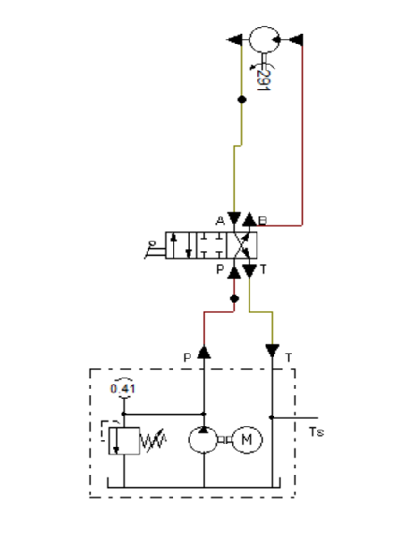

1. **4/3 valve to operate Bi-Direction Motor**

A valve could be specified as 4-way, 3-position direction control valve or 4/3 DCV since there are four ports and three switching positions for the valve

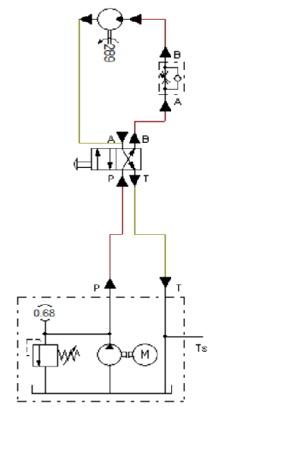

Conclusion:-

We learned in depth about meter in circuit , meter out circuit and Bleed off circuit , and understood the working of these circuits. We operated the Bi-directional motor using 4 /2 valve and 4/3 valve